**Zayad**

# CHAPTER FOUR

# SYSTEM DESIGN AND IMPLEMENTATION

# INTRODUCTION

There is need for one to design system by showing what the system entails, identifying and defining the various components of the system before the actual implementation. The whole aim is to determine how the information can be built. This gives the design the chance of making a choice of the way the problem can best be solved.

# SYSTEM DESIGN

System design is the process of defining the architecture, component, modules, and interface so as to satisfy a specified requirement. System design could be seen as the application of the systems theory to products development.

The Unified Modeling Language is the most common form of software development tool in computerizing the system that is to be constructed. It provides a better way of visualizing the design of a system. It provides a clear view of the problem and also provides a way in which the users of the system can interact directly with the system.

The UML is a standard representation devised by the developers of widely used oriented analysis and design.

# PHYSICAL DESIGN

The physical design relates to the actual input and output processes of the system. This is explained in terms of how data input into a system, how it is verified/authenticated, how it is processed, and how it is displayed.

# Input Design

Input applies to any data that is feed up into the system for that system to provide efficient and effective result information. Thus, the input design specifies the manner in which data enters the system for processing.

# Output Design

The Output is the product of the user; it is the most valuable visible component of working information system. A system value is based on the output it produces. This system is able to generate the following outputs: The Preview Report, Print the Report, Plate Number Generated, and Total Plate Number in Store, Total Plate sold and Total Registered Customers.

# LOGICAL DESIGN

The logical design of a system pertains to an abstract representation of the data flows, inputs and outputs of the system. This is often conducted via modelling, using an over-abstract (and sometimes graphical) model of the actual system. In the context of systems, designs are included.

# SYSTEM IMPLEMENTATION

Implementation is the realization of a technical specification or algorithm as a program or software component. It involves the accurate transform at or of the software design into some executable program code using Microsoft Visual Studio 2015. A design may be implemented in various ways depending on the priorities of the software developer. In this work, several factors were taken into consideration during implementation. These factors include:

# Correctness

The implementation was carried out with the aim of the final product meeting the user’s need.

# Robustness

Robustness is the quality of being able to withstand stresses, pressures or changes in procedure or circumstance. Robustness was emphasized extensively in the implementation of this work. Defensive programming techniques were applied. Strict checking procedures were included to eliminate the possibility of unacceptable effects on system response.

# Performance

Software performance is the extent to which a product meets its constraints with regard to response or space requirements. Performance optimization especially as regards speed / response time and appropriate search techniques were employed to ensure good response time.

IMPLEMENTATION TOOLS Front End

* **Microsoft Visual Studio**

Is an integrated development environment (IDE) from Microsoft. It is used to develop computer programs, as well as websites, web apps, web services and mobile apps. Visual Studio uses Microsoft software development platform such as Windows API, Windows Forms, Windows Presentation Foundation, Windows Store and Microsoft Silverlight. It can produce both native and managed code.

# Back End

* **Microsoft Access**

Microsoft Access Database is a database management system (DBMS) that combines the relational Microsoft Jet Database Engine with a graphical user interface and software development tools.

# SYSTEM REQUIREMENT

These are the requirements that must be available for the successful implementation of the new System.

# Hardware Requirements

The required hardware for the system to operate are:

The System must be running Windows Operating Systems only.

* + - * + For Windows 98 based computers, a 500/88MHz or higher processor with 32 Mb of RAM
        + For Windows Vista based computers and higher, a 1GHz or Higher processor with 1GB of RAM.

Input Devices: Mouse and Keyboard

# Software Requirements

For the Software requirements these mainly consists of:

* + - * + Microsoft Office i.e. Microsoft Access 2013 for the database.
        + Microsoft Visual Studio 2015.
        + Operating System: Windows 98, Windows XP, Windows 7 and higher.

# SYSTEM TESTING

System testing is the process of examining a computer program to ascertain its working and function as stated. The system testing enables the system developer to detect and locate an error or errors encountered. The role of testing is to ensure that a system is free of error.

It also ensures that the program function appears to be running according to specification and that requirements have been met. The system is tested based on the following testing approaches:

# Unit Testing

This is a testing strategy in which each and every program module is tested separately. The modules tested using this approach are as follows:

* + Login Form to allow Login
  + Vehicle Information and Owner’s Information form
  + Plate Number Generation panel

# Integration Testing

This is a testing strategy in which program modules are tested as the whole. The modules are all integrated in this strategy of testing.

* + Considering the dashboard, all the buttons that are linkage to another form which are all tested using this method.

# PERFORMANCE EVALUATION

The main aim of this project is to deliver effective information and management services. It is a software-based application to deliver operational speed and service efficiency. The project “Automatic Plate Number Generator” is very accurate in its approach and suits all environments. In evaluating the system, it is observed that the project is successful. It is designed and tested to provide the following benefit:

1. Provides an opportunity to the management to enhance their record keeping system and also increases the profitability of the organization.
2. The management now require smaller number of staff to cater for more Applicants in the same time or even less.

The System enable the organization to serve the rapidly growing number of customers in a cost- effective manner.

# CHANGE OVER PROCEDURES

Changeover is concerned with the smooth shift from one way of doing things to another and the mitigation of disruption to business activities during the changeover. There are three main methods used: phased implementation, direct changeover and parallel running.

**Phased implementation**: A staged method whereby one part of the overall system that need changing is changed. If any problems arise, they are limited in scope and therefore non-critical. Once the system has been successfully changed in one area, the other areas can follow suit, with any lessons learned during the initial changeover used to ensure the success of the changeover as a whole.

**Parallel running**: Both the old and the new systems run side-by-side, using live data, so that project managers can compare the efficiency and reliability of the new system. Once they are satisfied, the old system is taken offline and the new system becomes fully active and utilized across the organization.

**Direct changeover**: There is a single, fixed point where one system stops being used and the new one becomes live. This is the cheapest, quickest and easiest form of system changeover but is also the riskiest.

# THE USER INTERFACES Login Form

The Login Form is the interface that allows the admin to enter his/her username and password in

order to 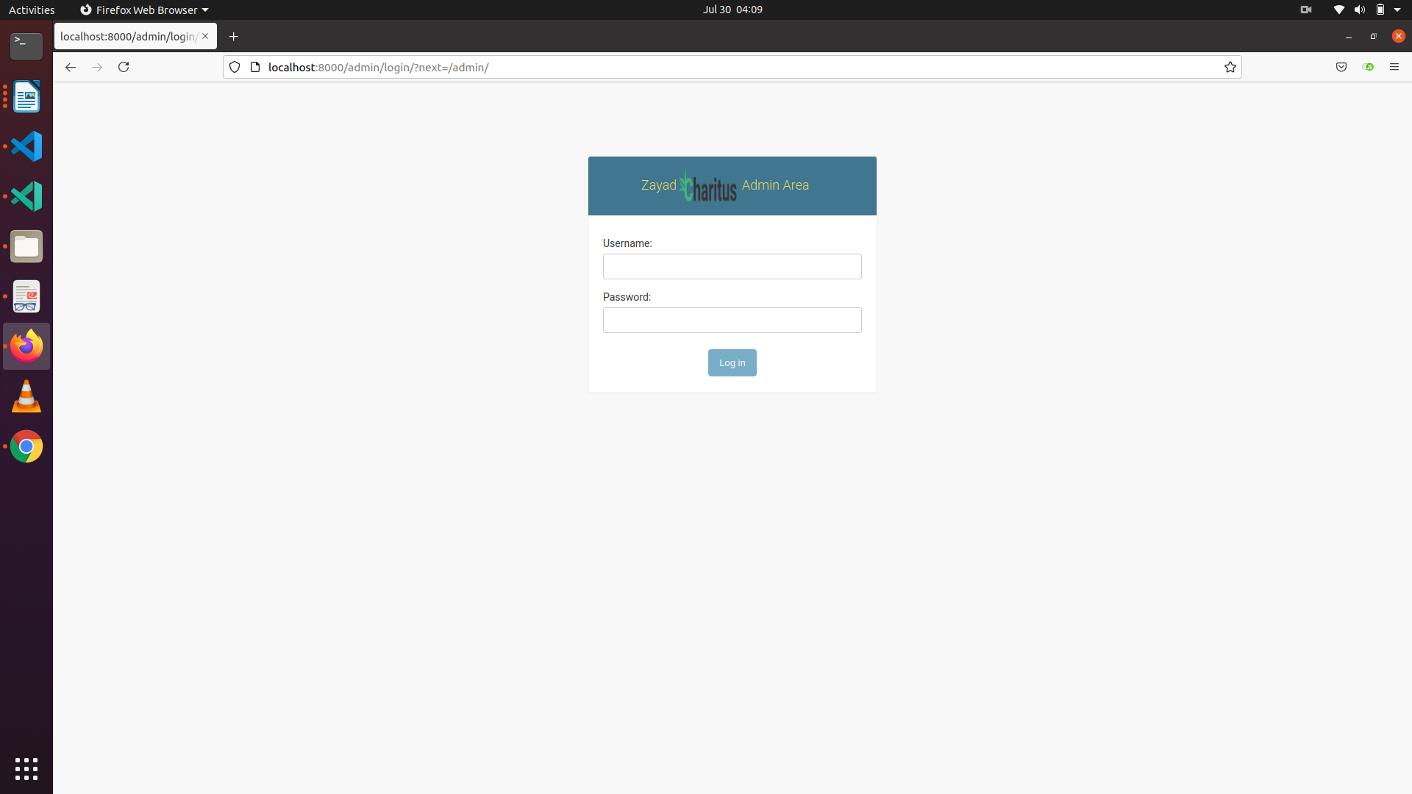login.

*Fig 4.1 Login Form*

# admin area

Admin area is the interface that monitor users and it activities, update information of the program

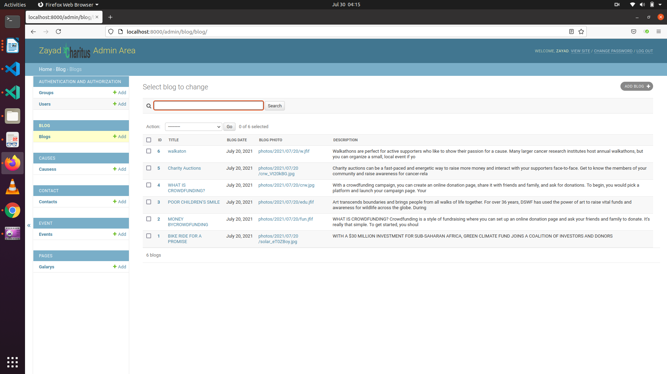

*Fig 4.2 admin area Screen*

# **HOME PAGE**

Home page interface consist of all the menus as well as the major activities in details

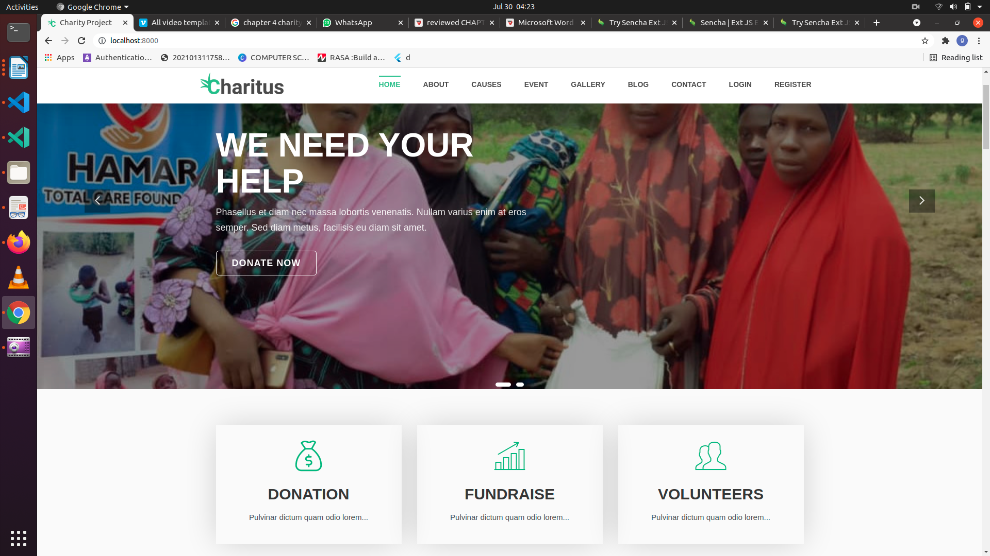

*Fig 4.3 Home page*

# Vehicle Information

Vehicle Information is an interface in which the vehicle details are added.

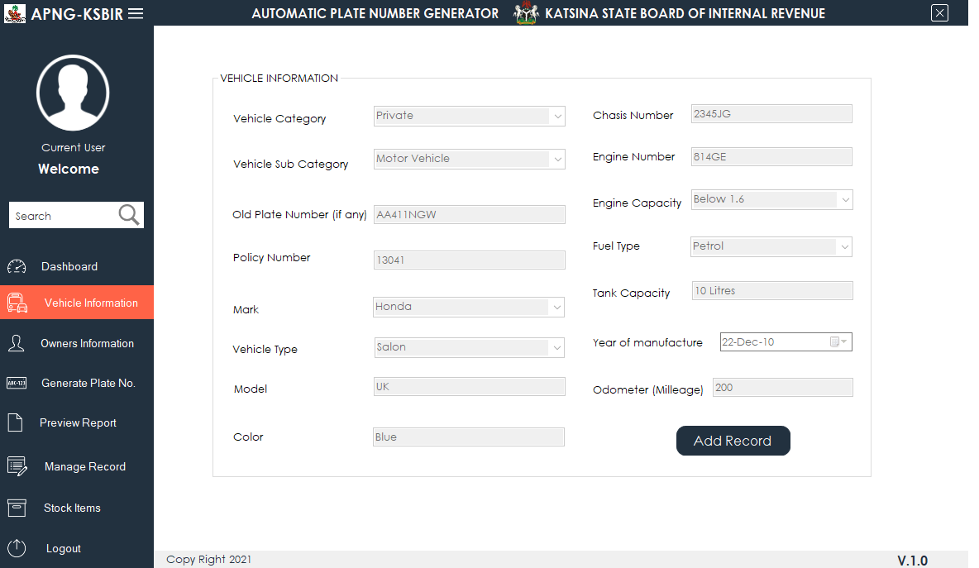

*Fig 4.4 Home Information*

# **Event** Information

Chairity Event Information is an interface in which give the detail information of upcomming event.

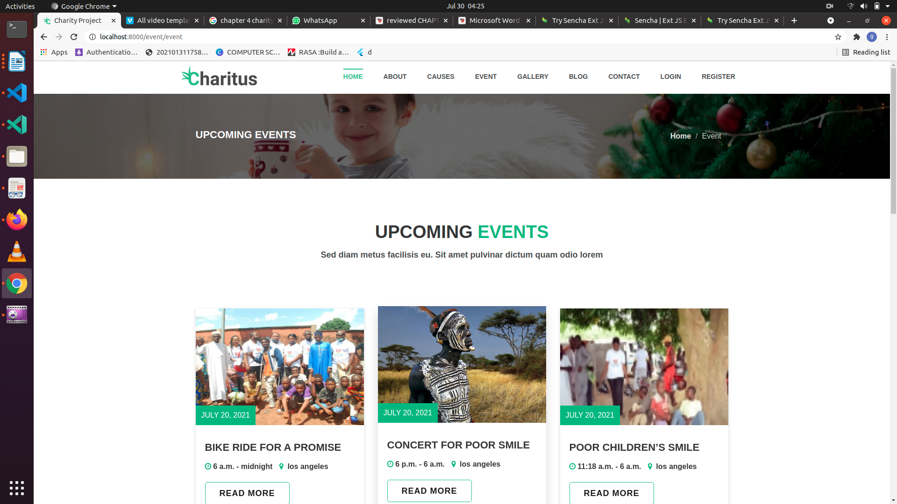

*Fig 4.5 upcoming event Information*

# **causes for donation**This is an interface in which **described the causes for donation**

*Fig 4.5 causes for donation*

online Donation

This is an interface where the online donation

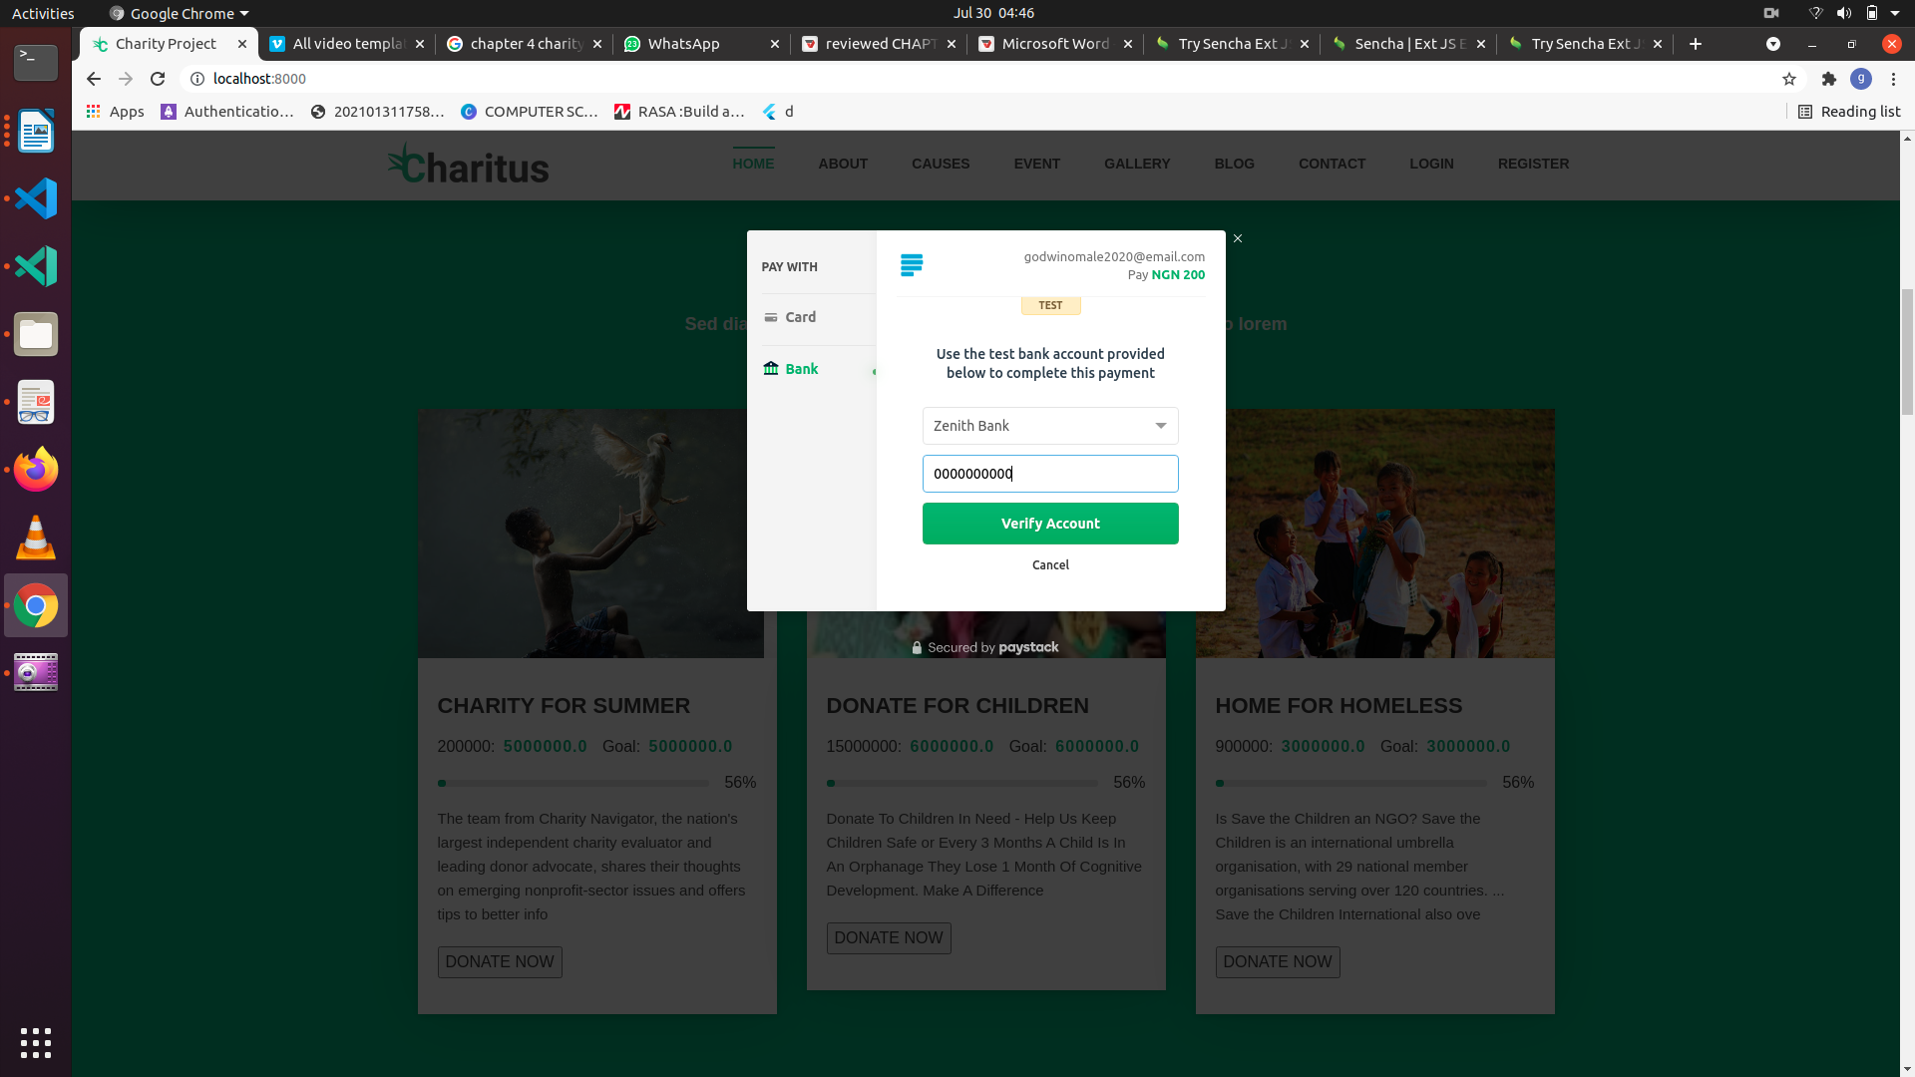

*Fig 4.6 donation*

# Manage Record

Manage Record interface is used to manage the stored record in the database which include updating and deleting a particular record.

*Fig 4.7 Manage Record*

# Stock Items

This is an interface in which the records about plate number stored which include total plate numbers, total registered customers, total plate sold and total plate in store.

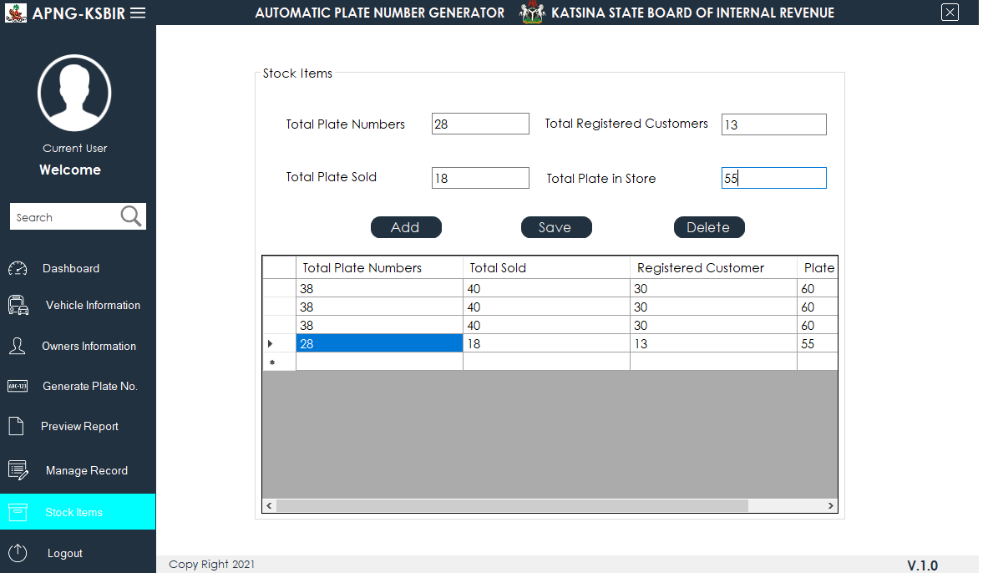

*Fig 4.8 gallery of previous event and achievers*

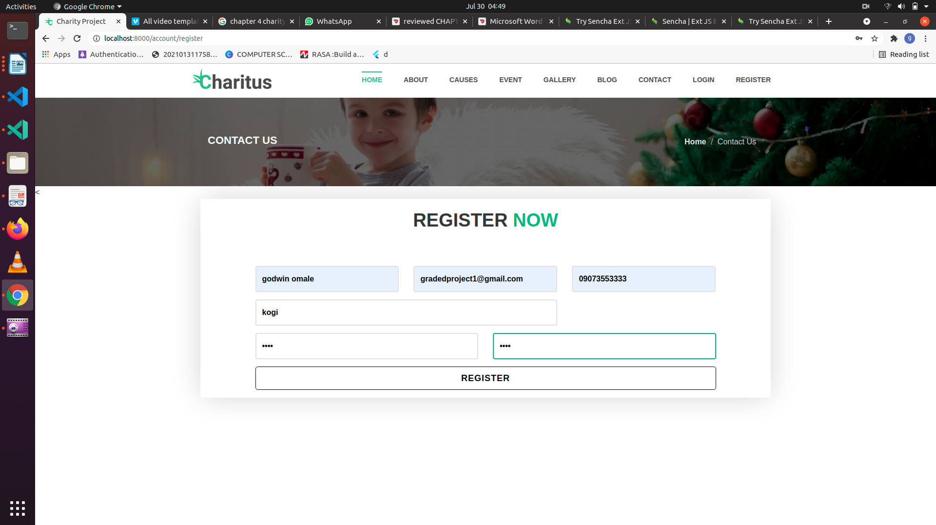

*Fig 4.8 users registration page*

**4.8 Test Report Summary (for Unit Testing, Integration Testing, and System Testing)**

Table 4.5: Test Summary Report

|  |  |  |
| --- | --- | --- |
| **NO Test Performed Action** | | |
| **1** | To test validation in Registration Page | Pass |
| **2** | To test Password and confirm Password in Registration Page | Pass |
| **3** | To Register a New User | Pass |
| **4** | The system shall allow a user to login. | Pass |
| **5** | admin add causes for donation | Pass |
| **6** | admin add events and news blog | Pass |
| **7** | Users view causes | Pass |
| **8** | Users make donation online | Pass |
| **9** | Admin showcase needy achievement | Pass |
| **10** | Contact admin | Pass |
| **11** | Users view detail of event and blog | Pass |

# DATABASE DESIGN

Database is a collection if interrelated record. The key word “interrelated” means that the record in each file must allow for relationship with the record in another file. The database used in this system was designed using Mysql Access which is a relational database management system (RDBMS). The most basic concept in the RDBMS approach is table. A table is made up of rows and columns. The actual data in the database is stored in table, each record in the table represent single individual.

# DESCRIPTION OF TABLES Table 4.1 **users** **registration**

|  |  |  |
| --- | --- | --- |
| **Field Name** | **Data Type** | **Size** |
| First Name | varchar | 40 |
| Last Name | varchar | 40 |
| Address | varchar | 225 |
| city | number | 40 |
| State | varchar | 30 |
| Local Government | varchar | 30 |
| Mobile No. | varchar | 20 |
| Email | varchar | 40 |

**Table 4.2 online donation Information**

|  |  |  |
| --- | --- | --- |
| **Field Name** | **Data Type** | **Size** |
| First Name | varchar | 40 |
| Last Name | varchar | 40 |
| Address | varchar | 225 |
| amount | number | 40 |
| State | varchar | 30 |
| Local Government | varchar | 30 |
| Mobile No. | varchar | 20 |
| Email | varchar | 40 |

# Table 4.3 **causes for donation**

|  |  |  |
| --- | --- | --- |
| **Field Name** | **Data Type** | **Size** |
| title | text | 20 |
| descriptions | Text | 255 |
| Target amount | number | 255 |
| Current amount | number | 255 |
| photos | blob | 100 |

**Table 4.4 event Items**

|  |  |  |
| --- | --- | --- |
| **Field Name** | **Data Type** | **Size** |
| title | text | 20 |
| descriptions | Text | 255 |
| photos | blob | 100 |
| date | date | 255 |

table 4.5 contact

|  |  |  |
| --- | --- | --- |
| **Field Name** | **Data Type** | **Size** |
| Full name | text | 20 |
| email | Text | 255 |
| Phone number | number | 255 |
| messages | number | 255 |
| date | date | 100 |

**4.10 Summary**

This chapter shows that overall implementation and testing of the project was carried out. It was a success, and a lot of issues were encountered during the test stage but was debugged and fixed eventually. Therefore, so far, the testing was a success because the components and functionalities are working fine.